Please read these rules carefully. A limit of two chariots per school is allowed. Failure to comply with the rules may result in disqualification:

Chariots will be judged in two contests. First, they will be judged for their appearance and creativity. Second, they will race one another. Depending on the number of entries, there will be qualifying races of 3 chariots each. Winners of each of these races will then compete in a final race for first, second, and third places.

- Chariots must be able to hold one student during the race and be pulled by no more than 2 students acting as the horses.
- All students involved must wear shoes (no sandals) and protective helmets (no costume helmets allowed). You may not race without a protective helmet (such as a bike or football helmet). We also recommend elbow and knee pads.
- The race will be a distance of about 50 yards ??? and will be clearly marked on the field.

Rules for building your chariot:

1. SOLID BASE

- For safety purposes, CHARIOT must have four wheels
- You can create a larger base on top of a smaller one
- You can create your own base, if you so desire
- Your chariot must be upright, on wheels, with charioteer IN the chariot when crossing the Finish Line, or chariot will be disqualified from race

2. PULPIT

- The front end must be fully enclosed up to the chest area of the driver
- The back end must be open
- The sides may taper down towards the back

3. PROPULSION METHOD: Only 1 charioteer; no more than 2 horses

- Bridle and bit method:
  - Attach ropes onto the chariot which are then tied to the waist of the horse/s (student/s)
  - length can vary according to the tendencies of the chariot and driver
  - Chariot on left in picture is an example

- Rickshaw method:
  - Two boards on either side extending out in front of the chariot with a yoke connecting them in front for the horse/s (student/s) (see middle chariot in picture)
  - Or, a single sturdy pole from the middle of the chariot with yoke in front for horse/s (student/s) (see right chariot in picture)

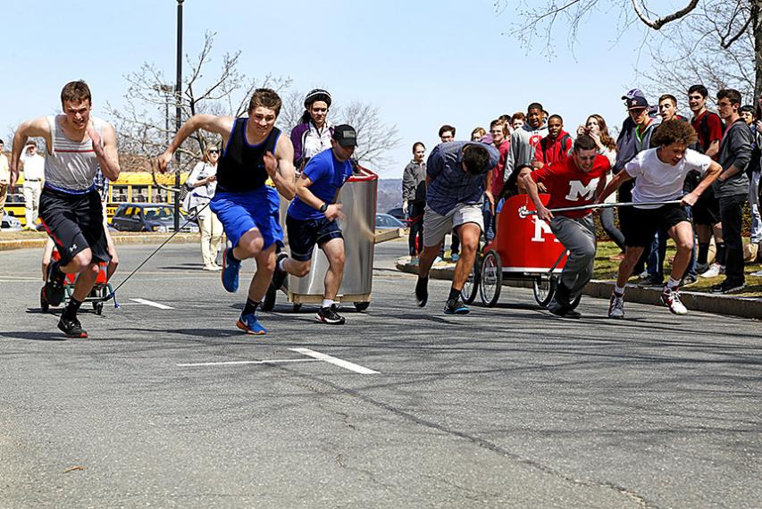

4. DECORATION

- Feel free to decorate your chariot in Classical motifs (please, no vulgarities or offensive materials). You will be judged on the chariot’s appearance as well as durability and speed.
- NO spikes or objects projecting from sides (i.e.--as in Ben Hur).

5. PRE-CLASSICS DAY TESTING

- Do not bring your chariot to Classics Day without having tested it for safety.
- All chariot participants must wear shoes and protective helmets.

Please be as creative as possible and have fun with this idea. Remember, chariots will be judged not only for speed in the race, but also for appearance/creativity.

