the Third Annual

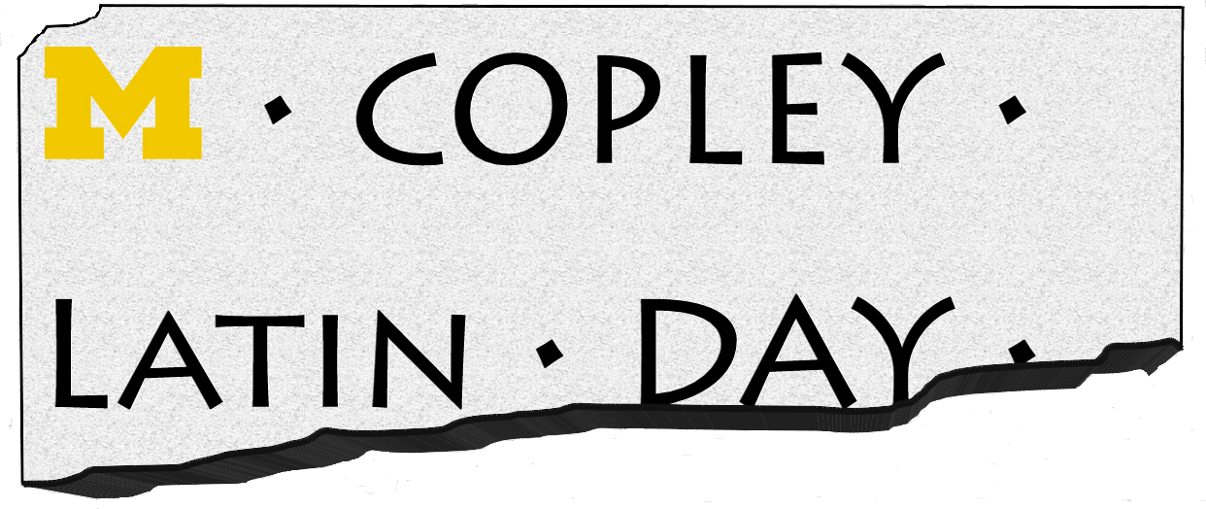

May 17, 2017

University of Michigan

Dept. of Classical Studies
Kelsey Museum of Archaeology
The Papyrology Collection at the U-M Library

MORNING PROGRAM

All events held at Colisseum and Elbel Field unless otherwise specified.

Arrivals
8:00 am – 9:00 am

For those arriving early, the Kelsey Museum will be open at 8:00 am for students to visit. There will not be any formal tours. The Kelsey Museum is located about a 15-minute walk (0.7 miles) from Elbel Field. Please plan accordingly to arrive in time for the Welcome Ceremony.

Welcome Ceremony
Colisseum, basketball court

9:00 am - 9:20 am

Welcome by Chair of Classical Studies, Prof. Sara Forsdyke

Welcome by CLD Organizers, Ruth Caston and Cathy Person

Roll Call of Schools

Reading of carmen saeculare
9:20 am – 9:35 am

Faculty Presentation
9:40 am – 10:15 am

Professor David S. Potter: “Sports in Antiquity”

Morning Activities:
10:20 am – 11:40 am

All students will be divided up into 4 groups and will spend 20 minutes with each activity. Activities relate to athletic competitions in Ancient Greece and Rome, like those of the Olympics. Each activity will begin with a brief introduction followed by a chance for students to compete within their groups.

Foot Races: Students will try their skills at 50 yard dashes and learn about foot races in the ancient world.

Long Jump: Another important event at athletic competitions was the long jump. In ancient Greece this was a series of three jumps in a row while holding halteres, 1 kilogram hand weights.

Frisbee Discus Throw: While the Greeks and Romans used a discus around 6 kilograms in weight, for this athletic event, students will learn about the motion of discus throwing using Frisbees.

Mask Making: All games and ludi included artistic competitions as well as athletic. For this activity students will have a chance to make masks for the theatrical performances later in the day.

Lunch:
11:40 am - 12:20 pm

Elbel Field is about a 15-minute walk (0.6 mile) from the Michigan Union for those wishing to purchase food. However, because of the tight schedule, we are asking students to please bring a brown bag lunch for picnic style dining on the field. If teachers wish, they may arrange to leave the morning activities a few minutes early to allow students to go to the Union, but PLEASE let us know this is your plan so those running the activities can plan accordingly.

We are providing water and granola bars throughout the entire day, but no meals.

During Lunch, chariots will be judged on appearance and creativity. The winners will be announced at the Awards Ceremony.

afternoon activities:
12:20 pm - 1:20 pm

We will come together in one group for our afternoon activities, which will begin immediately at 12:20 pm.

Chariot Races:
12:20 pm – 12:50 pm

Students racing must be ready to race by 12:20 pm. We will begin promptly with the first qualifying race. Each race will have no more than three chariots competing at a time for safety. The number of these races will depend on how many enter. The winners of each of these will then compete in one final race to determine first, second, and third places.
REMEMBER: Students in these races MUST wear protective helmets and shoes. We also recommend elbow and knee pads.

Theatrical Performances:
12:55 pm – 1:25 pm

Each school that chooses to compete will be invited up to perform a scene selection from a play by either Plautus or Terence. Selected scenes were provided in Fall 2016 for schools to prepare. Students will be judged on performance and creativity.

closing ceremony:
1:30 pm - 1:40 pm

Awards Ceremony for chariot and theatrical performance competitions.

Procession of competitors.

The Kelsey Museum and the Classical Studies Department will be offering drop-in tours from 1:45 pm – 2:45 pm for schools who have time to visit before leaving.

